Blissful Faith

501(c)(3) Nonprofit Organization

Shelter With In-House Human Trafficking Victim and Survivor Programs Plan

by

Blissful Faith Board

October 31, 2022

Contents
- Introduction……………………………………………………………………………… 1

- General Overview and Rationale………………………………………………………... 1

- Region Relevance ……………………………………………………………………… 3

- Place Relevance ...……………………………………………………………………… 7

- Movement Relevance ……………………………………………………………………8

- Human-Environment Interaction Relevance …………………………………………….8

- Budget ……………………………………………………………………………………8

- Summary………………………………………………………………………………….8

- References ……………………………………………………………………………. 8

Introduction
In this paper, we will explain how providing a shelter with multiple in-house services (i.e., victim and survivor reintegration programs) for demographics at-risk for exploitation (i.e., human trafficking) in Anchorage, Alaska or Eagle River, Alaska will serve several peoples groups across different ethnicities with the end goal being self-sufficiency of victims and survivors. Christian approaches to this issue include cross-cultural servanthood evangelism, prayer, good stewardship of resources, and ethical management. The main themes of geography (location, place, region, movement, and human-environment interaction) will be used to explain the previously listed Christian approaches to form a proposal.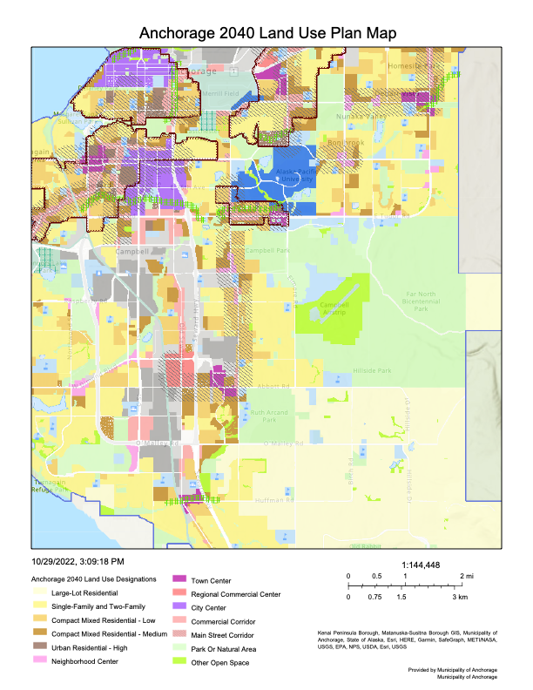
Figure 1. Credit: GIS Online (2022). Anchorage 2040 Land Use Plan [Map]. Anchorage Municipality GIS Online. https://utility.arcgisonline.com/arcgis/rest/directories/arcgisoutput/Utilities/PrintingTools_GPServer/x_____xV1rsjjnow-OX5TQJ45zMbQ..x_____x_ag

General Overview and Rationale
Anchorage, Alaska, is the epicenter for human trafficking in the United States with avenues including forced labor and the sex trade. A database released from the International Organization on Migration from 2002-2018 consisted of more than 50,0000 cases of which 27.4% of trafficking victims were 17 years old and younger, with almost one-quarter of minors being between the ages of 9 and 17-years-old (Psychiatric Annals, 2021).
Several nonprofit programs exist that aid victims of trafficking in Anchorage. These programs include Covenant House (housing, shelter services, education and employment, youth enrichment, pastoral ministry, etc.), Priceless (mentorship and resource connection for sex trafficking victims, Engage training to equip those looking to help the marginalized, Cyber Team that provides low-level tracing, etc.), among others. These nonprofits are in different districts such as Midtown or Northeast Anchorage.
Providing a shelter that is neither age-limited nor ethnicity-limited and has the capacity for several in-house resources such as employment, advocacy, and survivor reintegration programs expand the horizon on trafficking victims serviced, additionally reducing transportation, and allowing for closer spatial relations through easier accessibility despite urban sprawl.

Region Relevance
An estimated 288,121 people live in Anchorage currently. Of this demographic, 49% are female, 11.1% are 65 years and over, 24.3% are under 18 years old, and 7.1% are under 5 years old. Ethnic categories include the following: Caucasian (61.2%), multiethnic (11%), Asian (9.8%), Hispanic or Latino (9.4%), American Indian and Alaska Native (7.5%), Black or African American (5.3%), Native Hawaiian and Other Pacific Islander (2.9%). Veterans composed roughly over 9.3% from 2016-2020 (Census Bureau, 2021). Tertiary services are largely provided within the economy with median monthly mortgage costs at $2,148, median gross rent at $1,310, and poverty levels at 8.8%.
Anchorage is classified as an administrative region consisting of state and federal laws and regulations. One federal law enacted in all 50 states is the Trafficking Victims Protection Act of 2000 that establishes methods of prosecuting traffickers, preventing human trafficking, and protecting victims and survivors (American Bar Association, 2022).

Place Prevalence
A longitudinal study over 15 years was conducted by Benoit-Bryan in 2011 that examined the characteristics of 15,000 runaway adolescents across the U.S. and the long-term effect of fleeing behavior on adult outcomes. Results revealed that Native American youth had the largest difference in runaway rates at 13% compared to their non-Native peers at 8.4% (Morton et al, 2019).
Homelessness among American Indian and Alaska Native (AIAN) communities is another concern. Further risk factors for exploitation within the AIAN communities are higher rates of pregnancy among minors, affordable housing shortages, delinquency, school drop-out, foster care involvement, and drug and alcohol abuse (Morton et al, 2019). Native Americans constituted 3% of all persons counted as homeless in 2015 administrative data (Morton et al, 2019).

Movement Prevalence
Erecting a shelter will require movement of people, material, goods, and information. Leasing a building would utilize tangible routes between tertiary services. Plumbing, water, sewer, telephone lines, street and road system considerations would already be implemented. Therefore, connectivity would be greatly enhanced. Challenges to movement include disruption in efficiency of routes (i.e., accidents, traffic, construction, transportation, etc.) and natural disasters.
Spatial diffusion is informal within Anchorage and its surrounding municipalities. According to the 2021 Anchorage census, 96.7% of individuals have had access to a computer, 92% have broadband internet, 94% of individuals 25-years-old and above graduated from high school and 36% hold Bachelor or higher degrees from 2016-2020. Therefore, comprehension on informational stimuli is a low priority concern in the non-isolated public. Comprehension, illiteracy, and language barriers are concerning with foreign nations trafficked into the U.S. and Alaska as well as within isolated Native populations.

Human-Environmental Interaction Prevalence
Alaska contains complex terrains including mountains and tundra only accessible by aircraft and has been exposed to several natural disasters. Connectivity, technology, and resources can be hindered significantly in the wake of these natural disasters. Conservation control, habitat management, and zoning are strictly enforced, helping to slow unnecessary urban sprawl and the outreach of poachers that would negatively affect natural resources, wildlife, and the economy. Due to these controls, there are no permanently alternating landscape developments such as canals or dams, allowing for preservation of trails and parks that can be utilized for integrated recreational activity for victims and survivors.

Budget
The best outcome for resource management, conservation, staff mitigation, and goods consolidation are the leasing of an existing building either insider or within proximity to Anchorage. Students can form a nonprofit within state regulations and be established for a year or research grant opportunities available to students. Two state-provided grant opportunities available to nonprofits are Strengthening Organizations and the Victim Compensation Formula. The Strengthening Organization grant is available for requests up to $10,000 each cycle. Free, state-provided victim advocacy training exists through the Office of Victims of Crime. Federal-provided grants are available on Grants.gov. A summary of budget costs is provided below.
Table 1. Credit: Faith Brock (2022). Business Planning in Victim and Survivor-Centered Approaches to Combat Human Trafficking Spreadsheet

Summary
The complex nature of social work and maintaining a structure relies on geographical framework (i.e., connectivity and spatial diffusion). Globalization combines local and regional systems into global systems, consequentially creating production and distribution interconnections (Howell and Paris, 2019). Mission fieldwork is most effective when globalization is understood from the victim and survivor perspective (i.e., exploitative opportunities) to create structures and programs and the perpetrator perspective (i.e., their sustainability and motives of injustice) as they are often influenced by geographical vulnerabilities.

References

American Bar Association (n.d.). ABA Policies on Human Trafficking. Human Trafficking Project Information. Retrieved October 29, 2022, from https://dev.americanbar.org/groups/human_rights/human-trafficking-/policies/

American Law Institute (n.d.). ALI Model Penal Code: Sexual Assault and Related Offenses, Tentative Draft Number 5. Sexual Assault and Related Offenses Information. Retrieved from https://www.ali.org/publications/show/sexual-assault-and-related-offenses/#-drafts

Anchorage Municipality GIS Online. (n.d.). Anchorage 2040 Land Use Plan Map. GIS online map of Anchorage. Retrieved October 29, 2022 from https://utility.arcgisonline.com/arcgis/rest/directories/arcgisoutput/Utilities/PrintingTools_GPServer/x_____xV1rsjjnow-OX5TQJ45zMbQ..x_____x_ags_b79d6175-57de-11ed-93fb-128668631e0d.pdf

Howell, M., & Paris, J. (2019). Introducing Cultural Anthropology: A Christian Perspective (2nd Edition). Baker Publishing Group. Print.

Morton, M. H., Chávez, R., & Moore, K. (2019). Prevalence and Correlates of Homelessness Among American Indian and Alaska Native Youth. Journal of Primary Prevention, 40(6), 643-660. https://doi.org/10.1007/s10935-019-00571-2

Moukaddam, N., Torres, M., Vujanovic, A. A., Saunders, J., Le, H., & Shah, A. A. (2021). Epidemiology of Human Trafficking. Psychiatric Annals, 51(8), 359-363. https://doi.org/10.3928/00485713-20210702-02

United States Census Bureau (n.d.). QuickFacts: Anchorage municipality, Alaska. Census Bureau information. Retrieved October 29, 2022, from https://www.census.gov/quickfacts/anchoragemunicipalityalaska

